Collaboration Engine

Table of Contents

Collaboration Engine — Full Requirements Document

Table of Contents

1 Executive Summary
- 1.1 Overview
- 1.2 Key Benefits

2 Objectives
- 2.1 Primary Objectives
- 2.2 Secondary Objectives
- 2.3 Success Criteria

3 System Overview
- 3.1 What is the Collaboration Engine
- 3.2 How Applications Use the Collaboration Engine
- 3.3 Who Uses the Collaboration Engine
- 3.4 High Level System Flow

4 System Architecture
- 4.1 Architecture Overview
- 4.2 Standalone Recording Flow Diagram

5 Onboarding and Authentication
- 5.1 How Applications Connect to the Collaboration Engine
- 5.2 External User Onboarding Flow
- 5.3 Internal User, Agent and Supervisor Onboarding Flow
- 5.4 NICE Authentication Integration
- 5.5 Session Creation
- 5.6 Session Expiry and Reconnection
- 5.7 Security Tokens

6 Business Rules
- 6.1 Application Registration
- 6.2 Users and Roles
- 6.3 How People Are Brought Into the Collaboration Engine
- 6.4 Connecting to the System
- 6.5 Before the Collaboration Starts — Bot Conversation
- 6.6 How a Collaboration Works
- 6.7 Accepting and Rejecting a Collaboration
- 6.8 What Agents Can Do
- 6.9 What Supervisors Can Do
- 6.10 Transferring a Collaboration
- 6.11 Chat Messages
- 6.12 Recordings and Storage
- 6.13 Colleagues Collaborating With Each Other
- 6.14 Availability and Limits
- 6.15 Who Can Access What
- 6.16 Keeping Data
- 6.17 Standalone Screen Recording

1 Executive Summary

1.1 Overview
The Collaboration Engine is a centralised, API-driven real-time communication platform built for the organisation. It enables any application within the organisation to provide live chat, screen sharing, video streaming, recording capabilities, and standalone screen recording to its users without building these features from scratch. The engine handles everything from bot conversations to human agent interactions, supervisor monitoring, data storage, and independent page-level screen recordings using SignalR and WebRTC.

1.2 Key Benefits
- Any application in the organisation can have chat and collaboration features without building them independently
- Agents can handle multiple users at the same time from a single interface
- Supervisors can monitor and join any live collaboration across all their applications
- All recordings and chat histories are stored consistently in Azure Blob Storage
- Bot conversations are stored permanently and can be used to improve the bot over time
- Client applications can record any page screen by including a single JavaScript snippet — no backend development required
- Standalone recordings use the same SignalR and WebRTC infrastructure as the rest of the engine — consistent and reusable
- The engine is generic — new applications can be onboarded without any changes to the engine itself

2 Objectives

2.1 Primary Objectives
- Build a single generic Collaboration Engine that any application in the organisation can use
- Enable real-time chat between users and agents with bot-first routing
- Allow agents to handle multiple users simultaneously with configurable limits set by each application
- Allow supervisors to silently monitor or actively join any live collaboration in their applicationStore all recordings and chat history in Azure Blob Storage linked to each Collaboration ID
- Retain all bot conversation messages permanently for bot training purposes
- Support seamless agent-to-agent collaboration transfers within the same application
- Enable internal employees to collaborate with each other directly through the same engine
- Enable client applications to record any page screen without any link to chat or collaboration using the same SignalR and WebRTC infrastructure already in the engine

2.2 Secondary Objectives
- Provide a single HTML file user interface that adapts based on the logged-in person's role
- Expose a clean and consistent API that client applications can integrate with quickly
- Maintain a full audit trail of all activity within the engine
- Support automatic screen share recording without manual intervention
- Allow client applications to configure their own capacity limits for agents
- Provide an embeddable JavaScript snippet that client applications can drop into any page to enable standalone screen recording using SignalR and WebRTC with zero backend development effort

2.3 Success Criteria
- At least one application successfully onboarded and using the engine in production
- Agents can accept and manage multiple simultaneous collaborations without performance issues
- Supervisors can view and join any live session within their application in real time
- All recordings are successfully stored in Azure Blob Storage with correct folder structure
- Bot messages are retained permanently and linked to the resulting collaboration
- Client applications can record any page screen using the embeddable JS snippet with real-time status updates delivered via SignalR
- The engine handles the expected number of concurrent users, agents, and supervisors without degradation

3 System Overview

3.1 What is the Collaboration Engine
The Collaboration Engine is a shared platform that gives any application within the organisation the ability to offer real-time chat, screen sharing, video streaming, agent-based support, and standalone page screen recording. Instead of each application building and maintaining its own communication features, they register with the engine and use it through a standard API.
The engine manages the full lifecycle of a collaboration — from the moment a user opens a chat window, through bot conversation, agent routing, live interaction, recording, and final storage of all content. It also manages standalone screen recordings for any page in a client application through a simple embeddable JavaScript snippet that uses the same SignalR and WebRTC infrastructure as the rest of the engine.

3.2 How Applications Use the Collaboration Engine
An application registers with the engine and receives an API key. The application uses this key to call the engine's API whenever a user opens a chat window or triggers a screen recording. The engine then takes over — creating sessions, routing users to agents, managing the real-time connection, storing all content, and managing standalone recordings. The application does not need to know the details of how any of this works.

3.3 Who Uses the Collaboration Engine
- External Users — customers or outside parties who need help through a client application
- Internal Users — employees who may need support or want to collaborate with colleagues
- Agents — employees who handle user requests on behalf of their application
- Supervisors — employees who oversee agents and monitor collaborations
- Admins — people who register and manage applications and users in the engine
- Bot — an automated assistant that handles conversations before routing to a human
- Client Application Pages — any page in a registered client application that includes the embeddable JS snippet can trigger standalone screen recordings via SignalR and WebRTC without any user login or chat session

3.4 High Level System Flow
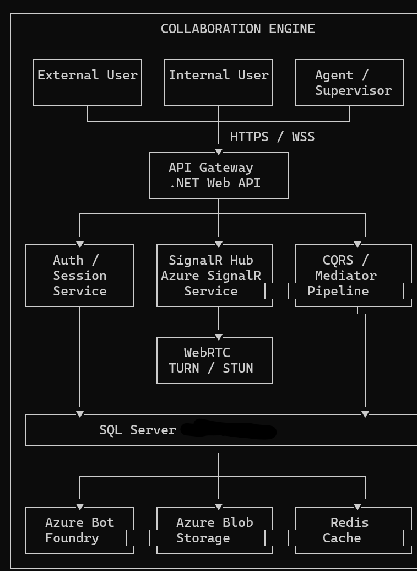

4 System Architecture

4.1 Architecture Overview
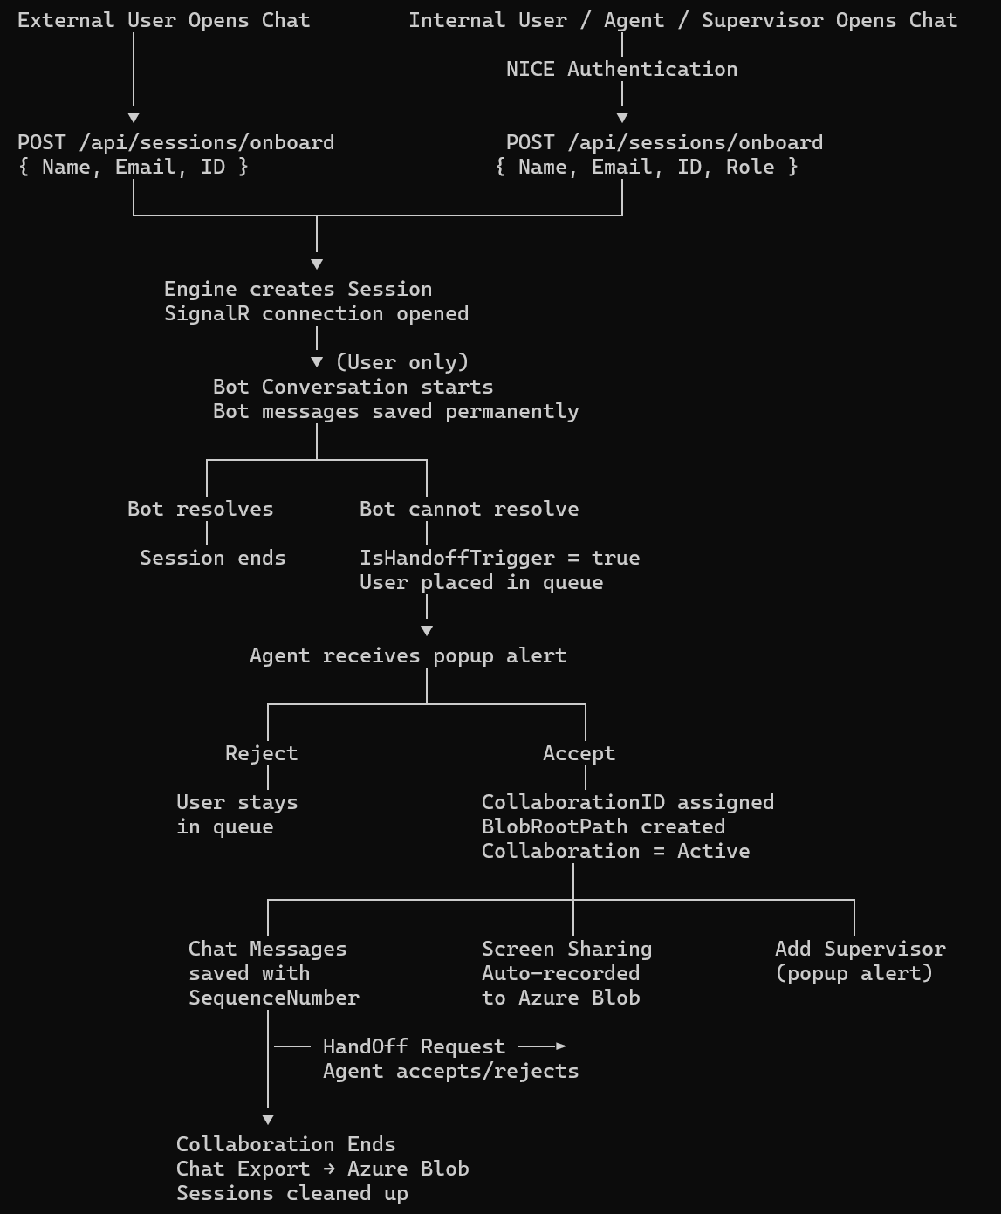

4.2 Standalone Recording Flow Diagram
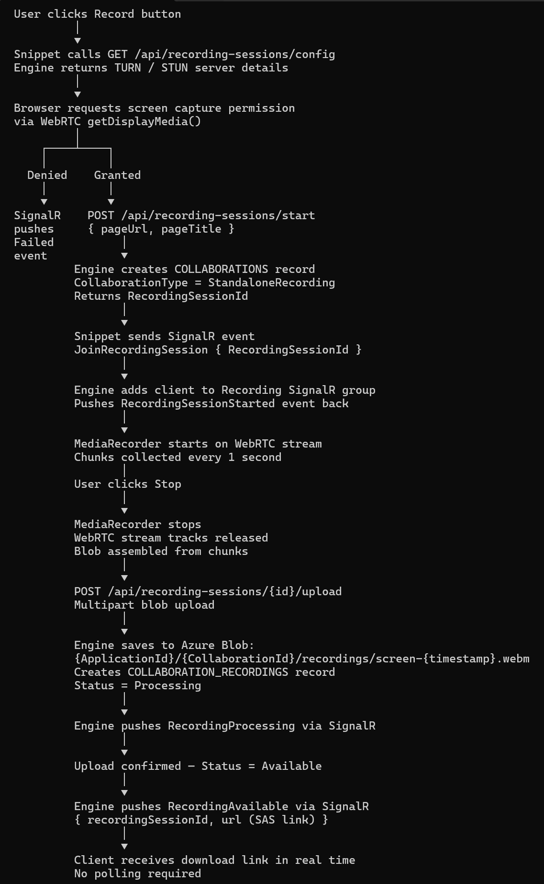

5 Onboarding and Authentication

5.1 How Applications Connect to the Collaboration Engine
Client applications connect by registering with the engine and receiving an API key. Every API call includes this key in the request header. The engine uses this key to identify which application is making the request and to enforce that application's settings and limits.

5.2 External User Onboarding Flow
- User opens the chat window in the client application
- The client application calls the Collaboration Engine API immediately
- The API call includes the user's Name, Email, and ID along with the application's API key
- The engine validates the API key to confirm the application is authorised
- The engine creates or updates the user's profile
- The engine creates a session for the user in Redis cache
- The engine returns session details and the user is connected to the real-time service

5.3 Internal User, Agent and Supervisor Onboarding Flow
- Person opens the chat window in the client application
- The client application runs NICE Authentication before calling the Collaboration Engine
- Once NICE Authentication succeeds, the client application calls the engine API with Name, Email, ID, and Role
- The engine validates the API key
- The engine creates or updates the person's profile
- For Agents and Supervisors the engine creates a session in both the database and Redis cache
- For Internal Users the session is created in Redis cache only

5.4 NICE Authentication Integration
The Collaboration Engine does not perform NICE Authentication itself. The client application is fully responsible for authenticating the user through NICE before calling the engine. The engine trusts that if a valid API key is present and user details are provided,the client application has already verified the person.

5.5 Session Creation
- A session is created for every person who connects regardless of their role
- Agent and Supervisor sessions are stored in the database for discoverability
- End-user sessions are stored in Redis cache only
- A unique session ID is returned to the client

5.6 Session Expiry and Reconnection
- Sessions have a configured timeout period
- Each action resets the timeout
- If no activity is detected a heartbeat check is sent
- If the heartbeat is not acknowledged the session is marked as expired
- On reconnection the person's session and active collaborations are restored

5.7 Security Tokens
- The engine issues its own session token on successful onboarding
- The token contains the person's ID, name, role, user type, application ID, session ID, and auth provider
- External users receive a shorter-lived token than internal users
- Tokens are never stored in the database

6 Business Rules

6.1 Application Registration
- Any application in the organization must sign up with the Collaboration Engine before it can use any of its features.
- When an application signs up, it receives a unique key to identify itself.
  - This key is kept secure and is never stored as plain text.
  - This key is used in every API call the application makes to the Collaboration Engine.
- Each application decides its own limits when signing up:
  - How many agents can be online at the same time
  - How many users can be connected at the same time
  - How many users a single agent can handle at the same time
    - This limit can be changed by the application at any time.
    - The new limit applies to all agents in that application immediately.
- An application can be turned off without losing any of its data.
- Each application can have its own dedicated storage space for recordings and collaboration history.
- An application can provide a web address to receive notifications when important events happen.

6.2 Users and Roles
- A person’s role depends on which application they are using, not who they are globally.
  - The same person can be an Agent in one application and a regular User in another.
  - The same person can be a Supervisor in one application and an Agent in another.
- There are three roles a person can have:
  - User
  - Agent
  - Supervisor
- There are two types of people:
  - Internal (employees)
  - External (customers or outside users)
- A person must be added to an application before they can use it.
- People are never permanently removed from the system; they can only be deactivated.

6.3 How People Are Brought Into the Collaboration Engine
- The Collaboration Engine is fully API-driven; every application connects its users through API calls.
  - The process begins when a user opens the chat popup inside a client application.
- For External Users:
  - When the chat popup opens, the client application immediately calls the Collaboration Engine API.
  - The client application sends the user’s basic details:
    - Name
    - Email
    - ID
  - The Collaboration Engine receives these details and creates the user’s session.
  - No login or password is required from the external user.
  - The client application is responsible for knowing who the external user is before calling the API.
- For Internal Users, Agents, and Supervisors:
  - When the chat popup opens, the client application first performs NICE Authentication on its side.
  - Once NICE Authentication is successful, the client application calls the Collaboration Engine API.
  - The client application sends the person’s details:
    - Name
    - Email
    - ID
    - Role
  - The Collaboration Engine receives these verified details and creates the person’s session.
  - The Collaboration Engine trusts the client application; the application’s key is the proof of identity.
  - The Collaboration Engine does not perform NICE Authentication itself.
- In both cases, the Collaboration Engine:
  - Creates or updates the person’s profile using the details provided.
  - Opens a real-time connection for them.
  - Returns the session details needed to start using the Collaboration Engine.

6.4 Connecting to the System
- A session is created for a person the moment the Collaboration Engine receives their details from the client application.
  - The session holds their identity, role, and connection details.
  - A real-time connection is opened immediately.
- Regular User sessions are kept only in fast temporary memory.
  - Not saved to the database.
  - Automatically removed when the user disconnects or goes inactive for too long.
- Agent and Supervisor sessions are saved to the database.
  - This is necessary so other people can find and reach them.
  - Also kept in fast memory for quick access.
- A person can only have one active session per application at a time.
- If a person goes inactive without disconnecting, their session automatically expires.

6.5 Before the Collaboration Starts — Bot Conversation
- When a user’s session is created, they are first connected to a bot before speaking with a real person.
- Every message exchanged between the user and the bot is saved permanently.
  - This data is kept to improve and train the bot over time.
  - When this data is used for training, it is marked so it is not used again.
- If the bot successfully helps the user, no further action is needed and the session ends normally.
- If the bot cannot help the user, it flags the collaboration and the user is placed in a queue to speak with a human agent.
- When a human agent eventually joins, all the bot messages are linked to that collaboration so the agent can see the full history.

6.6 How a Collaboration Works
- A Collaboration officially starts only when a User and an Agent are connected together.
  - At that moment, a unique Collaboration ID is created by the Collaboration Engine.
  - Everything that happens (messages, recordings, participants) is linked to this Collaboration ID.
- A Collaboration goes through stages:
  - Waiting for an agent
  - Agent joined and active
  - Paused / Being transferred
  - Finished or Abandoned
- Every Collaboration belongs to one specific application.
- There is always one main Agent responsible for the Collaboration at any time.
- When a Collaboration starts, a dedicated storage folder is created for it in the cloud.
- An Agent can pause a Collaboration if needed.
- A Collaboration can be ended by the User, the Agent, or a Supervisor.
- If the Agent loses connection during a Collaboration:
  - The Collaboration is automatically paused.
  - The user is notified that the agent disconnected.
- When a Collaboration ends:
  - A full record of all chat messages is saved to the storage folder.
  - Everyone involved is marked as having left the Collaboration.

6.7 Accepting and Rejecting a Collaboration
- When the Collaboration Engine assigns a User to an Agent or a Supervisor, the Agent or Supervisor receives a popup alert.
  - The alert shows the user’s details and the reason for the collaboration request.
  - The Agent or Supervisor must either accept or reject the alert.
- If the Agent or Supervisor accepts:
  - The Collaboration officially starts.
  - The Collaboration ID is assigned.
  - Both the User and Agent are connected.
- If the Agent or Supervisor rejects:
  - The user remains in the waiting queue.
  - The Collaboration Engine looks for the next available Agent.
- If the Agent or Supervisor does not respond within a set time:
  - The alert expires automatically.
  - The user is placed back in the queue.
  - The Agent’s availability is reviewed.
- The same popup alert applies when an Agent transfers a Collaboration to another Agent.
  - The receiving Agent must accept or reject the transfer request.

6.8 What Agents Can Do
- An Agent must be added to an application before they can handle collaborations for it.
- An Agent can handle more than one user at the same time.
  - The maximum number is set by the application they belong to.
  - When they reach the maximum, they are automatically shown as unavailable for new collaborations.
  - When a Collaboration ends, their availability is automatically updated.
- An Agent can set themselves as Away when they are not available.
- An Agent can see which other Agents in the same application are free to take over a Collaboration.
- An Agent can see which Supervisors in the same application are available to join their Collaboration.
- An Agent can pause or end a Collaboration.
- An Agent can transfer a Collaboration to another Agent in the same application.
- An Agent can invite a Supervisor to join an ongoing Collaboration.
- An Agent can start and stop recording a Collaboration.

6.9 What Supervisors Can Do
- A Supervisor must be added to an application before they can monitor it.
- A Supervisor can see all live Collaborations happening in their application at any time.
- A Supervisor can join any live Collaboration on their own to observe it.
  - When they join on their own, they enter in silent mode by default.
- A Supervisor can be invited by an Agent to join a specific Collaboration.
  - When invited, they receive a popup alert to accept or reject.
  - When accepted, they join as a visible and active participant.
- When a Supervisor joins silently:
  - The Agent and User do not know the Supervisor is watching.
  - No announcement is made in the Collaboration.
  - The Supervisor can watch the live stream.
  - The Supervisor cannot send messages.
- When a Supervisor is invited and joins actively:
  - Everyone in the Collaboration is notified that a Supervisor has joined.
  - The Supervisor can send messages and watch the live stream.
- A silent Supervisor can choose to step in and become an active participant at any time.
  - Everyone in the Collaboration will be notified when this happens.
- More than one Supervisor can watch the same Collaboration at the same time.
- A Supervisor can browse and watch all recorded Collaborations in their application.
- A Supervisor can leave a Collaboration at any time.
- A Supervisor who is busy can still join or be added to Collaborations.

6.10 Transferring a Collaboration
- An Agent can transfer a Collaboration to another Agent only within the same application.
  - Transfers to agents in a different application are not allowed.
- An Agent cannot transfer a Collaboration to themselves.
- The Agent receiving the transfer must be available and not at their maximum limit.
- Only one transfer request can be active per Collaboration at a time.
- The receiving Agent gets a popup alert to accept or reject the transfer.
  - The alert shows the Collaboration details and the reason for the transfer.
- A transfer request automatically cancels if the receiving Agent does not respond within a set time.
- While a transfer is being requested, the Collaboration is marked as being transferred.
- If the receiving Agent accepts:
  - They become the new main Agent for the Collaboration.
  - The original Agent stays in the Collaboration but steps back to a supporting role.
  - A notice is posted in the Collaboration that it has been transferred.
- If the receiving Agent rejects or the request times out:
  - The original Agent remains in charge of the Collaboration.
- A full history of all transfer requests is kept permanently.

6.11 Chat Messages
- All messages between people in a Collaboration are saved and linked to that Collaboration.
- Messages are numbered in order so they always appear correctly and can be replayed.
- A person can reply directly to a specific message to keep discussions organised.
- Files and images can be shared in the chat and are stored in the Collaboration’s storage folder.
- Messages are never permanently deleted; they are only hidden.
- The Collaboration Engine automatically posts notices in the chat when important things happen:
  - When a Collaboration is transferred to a new Agent
  - When a Supervisor visibly joins or leaves
  - When a Collaboration is paused or resumed
  - When a Collaboration ends
- No notice is posted when a Supervisor joins silently.

6.12 Recordings and Storage
- All recordings and files for a Collaboration are stored in a dedicated folder.
  - Folder path follows: Application → Collaboration ID → recordings
  - The full chat history is also saved as a file in this folder when the Collaboration ends.
- A Collaboration can have multiple recordings of different types:
  - Screen recording
  - Audio recording
  - Video recording
  - Chat history export
- Only an Agent or Supervisor can manually start and stop a recording.
- Screen sharing is automatically recorded:
  - When a user starts sharing their screen, the Collaboration Engine automatically starts recording it.
  - No manual action is needed from the Agent or Supervisor.
  - The recording stops automatically when the user stops sharing their screen.
- Supervisors can browse and access all completed recordings in their application.
- Links to access recordings are created fresh each time they are needed.
  - They are not stored permanently and expire after a set time for security.
- The chat history file is automatically saved when a Collaboration ends.

6.13 Colleagues Collaborating With Each Other
- All internal employees can start a Collaboration with each other regardless of their role.
  - This includes Users, Agents, and Supervisors.
- Employees can reach anyone in the organisation, not just people in the same application.
- One-to-one Collaboration:
  - Two employees connect directly with each other.
  - Starts immediately (no bot and no waiting queue).
- Group Collaboration:
  - One employee creates a group and adds members.
  - The creator can give the group a name.
  - New members can be added to the group at any time.
- Internal Collaborations still get a unique Collaboration ID from the Collaboration Engine.
  - All features (messaging, recordings, and storage) work the same way.
- There is no bot involved in internal Collaborations; people connect directly.

6.14 Availability and Limits
- The maximum number of simultaneous Collaborations per Agent is decided by the application, not by the Agent.
  - This can be changed at any time by the application and applies immediately.
- The Collaboration Engine automatically manages whether an Agent appears as available or unavailable:
  - Available: Agent has room for more Collaborations.
  - Unavailable: Agent has reached their maximum number of Collaborations.
  - Away: Agent has manually marked themselves as unavailable.
- Supervisors can mark themselves as Away but can still join Collaborations even when busy.
- If an application has reached its maximum number of online Agents or Users, new connections are not allowed until space becomes available.

6.15 Who Can Access What
- Every person must have an active session to use anything in the Collaboration Engine.
- Each role has a specific set of things they are allowed to do:
  - Admin: Registers applications and manages users.
  - Agent: Manages their own Collaborations, transfers, recordings, and inviting supervisors.
  - Supervisor: Views all Collaborations and recordings in their application; monitors and joins sessions.
  - User: Participates in their own Collaboration and sends messages.
  - Bot: Can only save and retrieve bot messages before a Collaboration starts.
- When a Supervisor is silently watching a Collaboration, no one in that Collaboration can see or find them.
- Access links to recordings expire after a short time and cannot be reused.
- An Agent can only see and work with Collaborations in their own application.
- A Supervisor can only see Collaborations and recordings in their own application.
- The Collaboration Engine trusts the calling application to verify who the users are before they connect.

6.16 Keeping Data
- Bot messages are kept forever to help improve the bot over time.
- Chat messages are kept forever.
- Collaboration records are kept forever as a permanent history.
- Transfer records are kept forever as a permanent record.
- Recordings are kept until they are manually deleted.
- Activity logs are kept forever and cannot be changed or removed.
- Agent and Supervisor connection records are cleaned up some time after they disconnect.
- Regular User connection records are automatically removed from temporary memory as soon as they disconnect.
- Pending system notifications are removed after they are successfully delivered.

6.17 Standalone Screen Recording
- Client applications can record any page screen using the Collaboration Engine without starting a chat or collaboration
- Each recording is anchored to a unique Recording Session ID which is the CollaborationId of a lightweight record created when recording starts
- The engine creates this record automatically when the client application calls the start endpoint — no manual setup required from the client side
- The standalone recording JS snippet connects to the Collaboration Engine SignalR Hub using the application API key — no user login required
- The engine provides TURN and STUN server details to the browser at connection time — the same server configuration used by all other WebRTC features in the engine
- Screen capture is performed using the WebRTC getDisplayMedia API in the browser with the TURN and STUN servers provided by the engine
- All recording lifecycle events are pushed to the client in real time via SignalR — the client does not poll for status updates
- The client browser joins a dedicated SignalR group for the recording session as soon as the session is created
- When the recording is available for download the engine pushes a RecordingAvailable event via SignalR containing the secure SAS download URL — no separate retrieval call is needed
- If the user denies screen capture permission the engine pushes a RecordingFailed event via SignalR with the reason
- Recording stops when the user clicks stop or closes the browser tab
- The recorded file is uploaded to Azure Blob automatically on stop — no manual upload required from the client application
- Standalone recordings can be retrieved at any time using the Recording Session ID
- Direct blob access is never permitted — all access through time-limited SAS links
- Standalone recordings appear in the same recordings list as collaboration recordings and can be filtered by type
- No new database table is required — standalone recordings reuse the existing COLLABORATIONS and COLLABORATION_RECORDINGS tables with CollaborationType set to StandaloneRecording

